

**Pandemic! Board Game**

*How to Play*

Philip Michael (40004861)

Amanda Friesen (27596189)

Johnny Mak (40002140)

Jason Kalec (40009464)

INSTRUCTION MANUAL

Group: Ants

Department of

Engineering & Computer Science

Presented in partial fulfillment of the requirements for COMP345

Professor: Nora Houari

*Advanced Programming Design in C++*

April 2017

**Table of Contents**

1. Starting the Game 2

2. Playing a Turn 3

2.1 Phase 1 3

2.2 Phase 2 5

2.3 Phase 3 6

3. Winning & Losing 7

# 1. Starting the Game

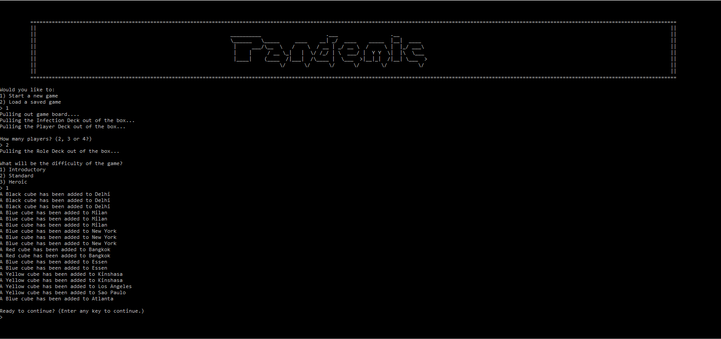

Upon starting the game, you will be prompted to choose to start a new game, or to load a previously saved game file. If this is your first time running the game, please start a new game. Then, you will be prompted to enter from two to four players that will be playing the game. When you decide on a number of players, enter it and the next step is to pick your difficulty setting. Our version of Pandemic features three difficulty modes: Introductory (for beginners), Standard (for second timers and people who want to just have fun and perhaps a quicker game), as well as Heroic (for veterans and people who like a challenge). Enter the associated number to the difficulty of your choosing, and press Enter. Finally, a quick notification output will be presented to you which lets you know of current board states. Do take note. And when that’s all done, press any key to proceed to the first player’s turn. You will be prompted, on a cleared screen, to press any key to continue to the first player’s turn. Only do that if you’re ready to save humanity!

# 2. Playing a Turn

## 2.1 Phase 1

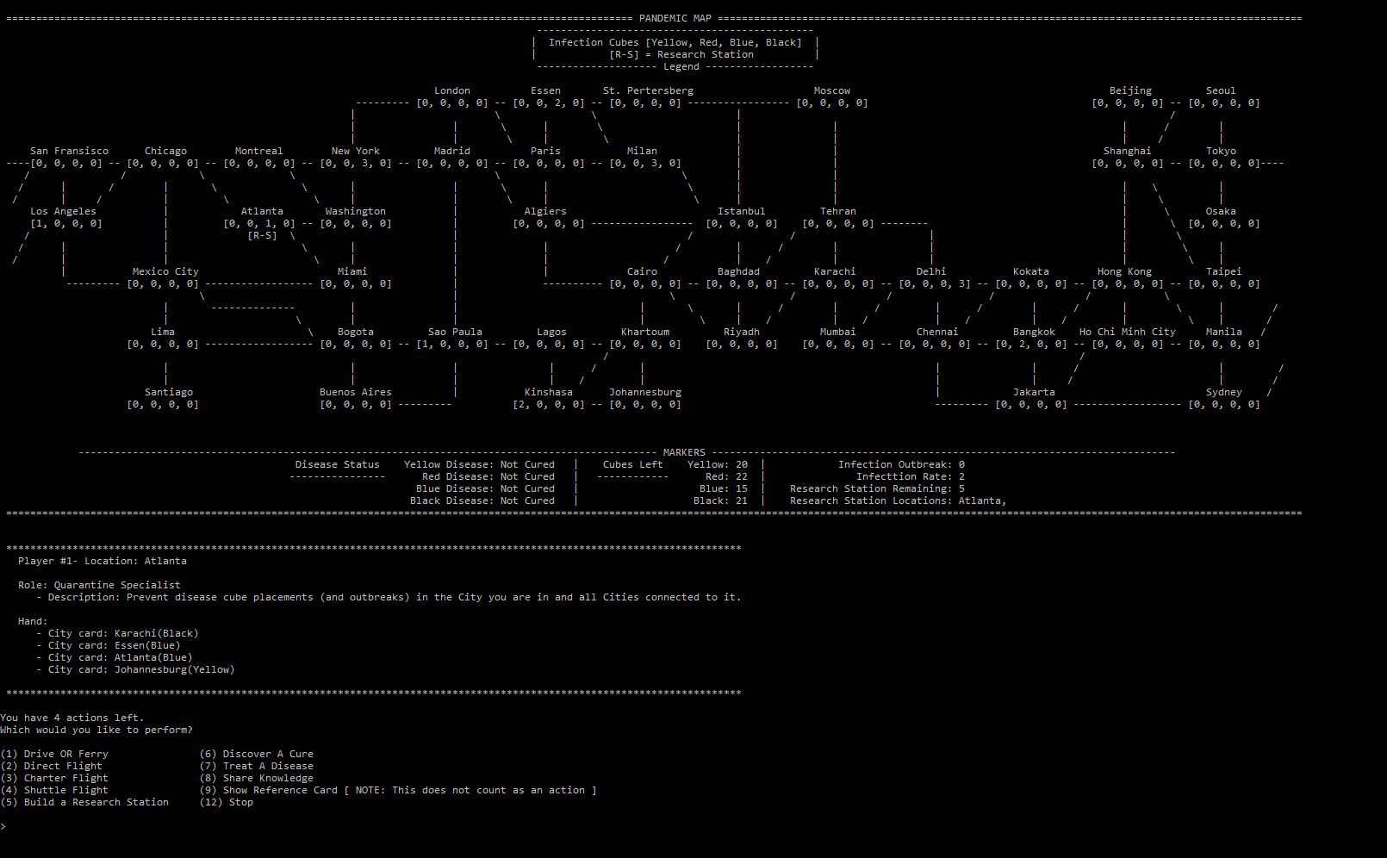

Upon beginning a turn, the map (game board) is shown to you with a quick legend outlining the infection cubes. We also present you with the Disease Status, Cubes Left, and outbreaks trackers (along with more information on research stations). Finally, the turn player’s information (which was assigned after shuffling cards and handing them out to each player) is presented, which includes the player’s role, location, and hand contents. Phase 1 then begins at this point.

In Phase 1, you can perform up to 4 actions (excluding your role’s unique action, if applicable). You can also stop to end your turn and move to the next player’s turn. If you decide to perform an action, you may notice the following:

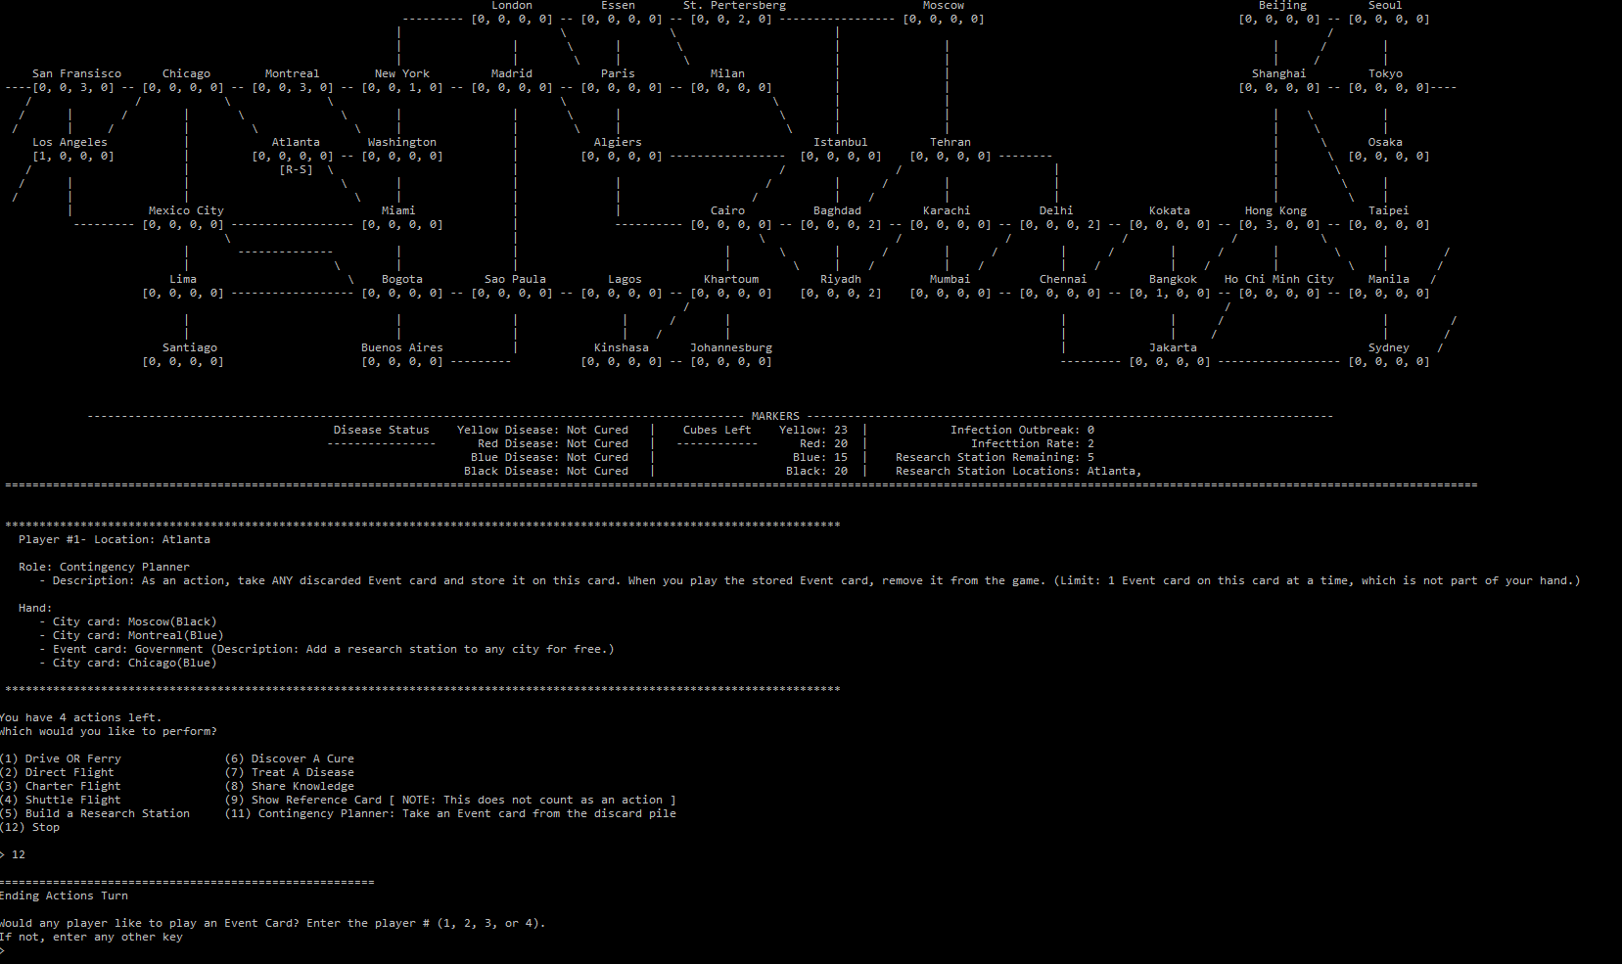

This prompts all players in case any of them wishes to play an Event Card. Follow the on-screen instructions if you do want to play one. In either case, when the first player’s turn ends, we move on to Phase 2.

## 2.2 Phase 2

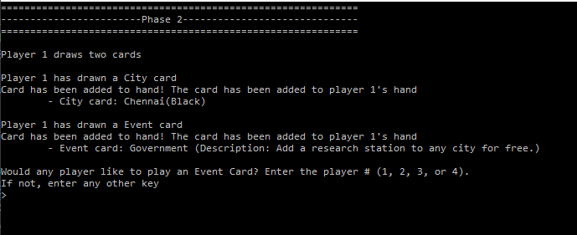

Phase 2 is broken down simply: the active player (that just ended his turn) will draw 2 cards. Each card will have its information printed out to the player, as well as an immediate up-to-date player hand contents. In this screenshot, you’ll notice that the player first drew the Event Card called “Resilient Population”. Then, the player drew a City Card called “Beijing”. All necessary information is shown to the player. Do be aware that Epidemic cards can also be drawn, and their unique interactions with the game will be handled. Players will be presented with all necessary information for that Epidemic. Finally, a prompt for Event Card actions is presented for any players to perform an Event Card if they so desire (as before in Phase 1). Finally, we move on to Phase 3.

## 2.3 Phase 3

Phase 3 is the infection phase. The turn player will draw 2 Infection Cards from the Infection Deck and infect appropriate cities.

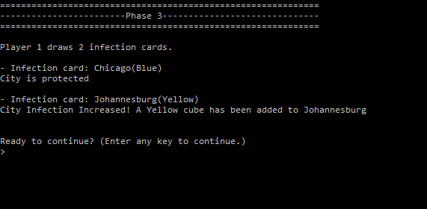

Phase 3 is broken down in individual steps for each drawn Infection Card to give players time to strategize. In the above screenshot, the first Infection Card drawn is Bogota (Yellow color). The map is thus printed out with up-to-date information following the infection that just took place, and finally a confirmation message is shown at the bottom for legibility. Similarly, the next drawn Infection Card is handled in the exact same way. At the end, you are prompted to continue to the next player’s turn.

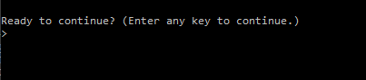

# 3. Winning & Losing

Now that you know how to play the game, your mission is to save humanity! Your roles *matter*! Event Cards are precious, use them carefully and intelligently!

Winning depends on your ability to cure *all* diseases found on the game board. You lose, however, if any of the following conditions are met:

* Outbreaks marker reaches the maximum (8 outbreaks);
* No more Player Cards to be drawn (draw pile is empty);
* No more disease cubes available to place.

This puts even more emphasis on cooperation. Pandemic is a game where you’re not against the other player, but rather against the game itself. Work with one another to cure all diseases, or humanity will perish! Best of luck and have fun! 😊